The Costume Society Ambassador’s Handbook 2022
The Costume Society is a lively, friendly organisation whose aim is to promote the study and preservation of historic and contemporary dress. Study days, the annual conference and online events give members an opportunity to keep up to date with the most recent scholarship and to visit museums, exhibitions and private collections of dress, fashion and textiles. Our dress studies journal, Costume, is published in March and September and members also receive a bi-annual Members' Magazine. And as a registered charity with educational aims, the Costume Society offers a number of grants and awards to students, researchers and trainee museum curators. As an Ambassador you play a key role in supporting the Society’s mission and have the opportunity to attend Costume Society events, share your passions, grow your network and create content for our social media platforms. Ambassadors are expected to post at least once a week across our social media platforms and can propose up to 4 blog posts a year as part of their duties. A schedule will be created by the Ambassadors’ Officer & Social Media Editor (see end of document).
Costume Society social media platforms:
- Blog (separate guidelines apply)
- Facebook
- Instagram
- LinkedIn
- Pinterest
- Twitter
- YouTube (currently managed by the Programme sub-Committee)
Platforms that need more attention e.g. Insta Live e.g. if you wanted to do an interview or tour. Pinterest for sharing images of garments (currently how the Instagram is being used, but content which should be on Pinterest).

Purpose of external comms platforms:
The Society’s social media should be lively, engaging, relevant, accurate and well-informed and ultimately reflects our charitable purposes. Our posts play an integral role in engaging diverse audiences with our organisation and sharing our passion for costume and dress history with other likeminded individuals and organisations, regardless of background or occupation.
- To engage with current CS members
- To highlight the work of current CS members in order to raise public awareness
- To drive attendance at CS events
- To promote the activities of the CS including its grants and awards
- To encourage potential new CS members
Going forward in 2022 we will have new schedule for social media and blog posts, so please do not follow the 2021 guidelines. Please start this new schedule from January 17th. This will give you all time to reach out to each department before commencing.
Each ambassador will work with one department for 4 months and then rotate.
The 3 departments are:
Costume (the journal of the Costume Society) – Editors Christine Stevens and Alexandra Kim
Events organised by Clare Bowyer Chair of Programme Committee
Grants & Awards organised by Lucy Johnston Vice-Chair Grants & Awards
Social Media Content Rotas:
Dates | Ambassador | Department
January - April | Wendy | Costume Journal
 | Annika | Events
 | Gemma | Grants & Awards
May - August | Gemma | Costume Journal
 | Wendy | Events
 | Annika | Grants & Awards
September - December | Annika | Costume Journal
 | Gemma | Events
 | Wendy | Grants & Awards
Before you start posting for each of these departments we have arranged for you to meet with the team to find out what events are happening during your slot, key information that you need etc.
Babette will share a draft social media post outline for your 4 months so you have some initial ideas of what would be good to share. As you can see from the schedule below, we have given outlines of content to share and some specific ideas we need shared on those dates.
You will each attend Costume Society events throughout the year, and then write a review for the blog which might also be included in The Thread. We currently anticipate 3 blog posts for each ambassador to write, so the blog post workload will be less for you all.
The Thread will now be published in June and December. For this content, Babette will contact you all in April and October.
Social media schedules:
Monday | #MembersMonday Members news highlight the news and successes of our members | Babette/Natascha will post on this day for the meantime
Tuesday | Events highlights from past events e.g. Reading Group, visits, conference and promote upcoming events including a drive to contribute and for ticket sales | Ambassador
Wednesday | ICYMI Blog promote the current blog post | Babette
Thursday | #ThrowbackThursday (as appropriate) Grants & Awards | Ambassador
Friday | Friends of the Costume Society and occasional #CSFashionHour (as scheduled) #CosSocFriends highlights news and events from other organisations of interest to our members. This can include the activities of our institutional members and ideally this should be a reciprocal activity. | Babette/Natascha will post on this day for the meantime
Saturday | Costume Journal highlight an article from Costume (see online archive) | Ambassador
Sunday | The Blog promote the new blog post | Babette

Format: Social media posts should be visually driven and written as per guidance above and as relevant for each platform e.g. you may wish to create a Tweet thread. You should incorporate relevant hashtags and link to individuals and organisations mentioned in your post as appropriate. The majority of social media posts are written in a conversational tone and aim to be accessible to a range of audiences who may not engage with traditional academic sources. Please always double check your spelling and grammar before sharing your post as it will be shared with our 50,000+ social media followers.
Each post should include a clear call to action (CTA) e.g.
- Have you read the latest issue of the Journal? Let us know your favourite article.
- Have you renewed your membership?
- Are you keen to find out more about becoming a Costume Society member? If so, direct message us with any questions.
- Read more about this iconic garment in the latest issue of the Costume journal.
- Did you know the Costume Society supports museum work through its MWEG Award, see the website for details of former recipients.
When it is your day to post, please share across all social media platforms. For example, Tuesdays are for events, so please share event info across Instagram, Facebook, Twitter and LinkedIn (if relevant).
Questions to ask before sharing content on social media:
- How does this relate to the Costume Society? i.e. does the post highlight our events, publications or awards?
- Does your post engage with current/prospective members and does it direct potential new members to the website for membership options?
- Was it a key talking point at a Costume Society event?
- How does it relate to the interests of our members? i.e. does the post highlight members’ activities and interests (academics, collectors, curators, general interest, independent researchers makers, reenactors, students).
Blog topics: Blog topics will be assigned by the News Editor and will fall under the following categories:
- Behind the scenes: exhibition reviews and/or interviews with curators.
- Costume drama: highlighting historical costume in film and TV.
- My favourite things: object-based interviews with bloggers, curators, collectors etc.
- Passion projects: ambassadors’ and/or members’ personal research and activities.
- The World of the Costume Society: highlighting events and activities of the Society.
The Costume Society has hosted a monthly #CSFashionHour on Twitter which takes the form of a debate, discussion or interview, Ambassadors can suggest topics for these.

Other social media posts can be to support Society events and activities or on any topic relevant to the Society’s mission.
Please make sure that sources are credible and that they are linked in your posts. Please source copyright free imagery e.g. Creative Commons, Europeana (Fashion), Getty Embed, press images, Unsplash or reshare posts from our partners/presenters with permission. Image content and rights usage to be referenced as appropriate. Ideas for content and details of upcoming events will be shared via the News Editor and Ambassadors’ Officer & Social Media Editor.
Draft events schedule:
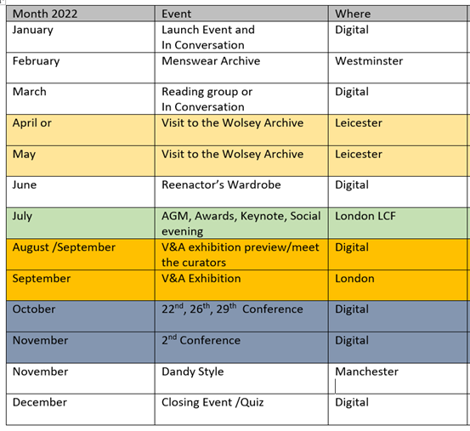
Draft Social Media Schedule:
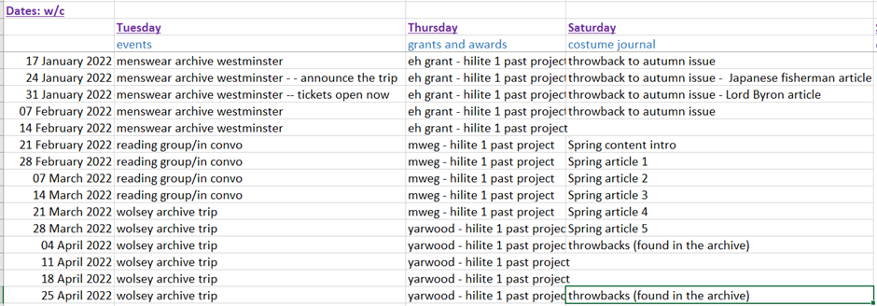

General
- The Ambassador’s Officer will organise a once every 6-week online meeting for you all to meet and chat, but do please feel free to meet up yourselves too At these meetings, we could invite people to speak in more detail about their costume expertise if you are keen. For example, if you want to know more about curation we could ask one of our experts to pop in digitally to speak with you all.
- We will also have minimum 3 comms committee meetings with you all throughout the year to see how this is all going.
- We will advertise and aim to recruit 3 more ambassadors in the spring.

Going forward, please do use email to contact us:
babettescarlet@gmail.com and natascha.RadclyffeThomas@gcu.ac.uk

